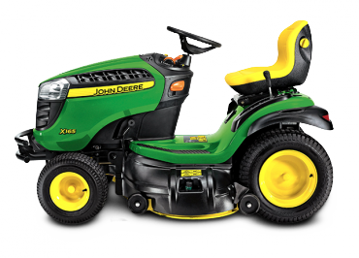p

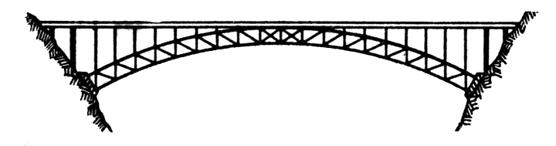

B R I D G E

Design Brief:

Design a bridge spanning a distance of 66 inches, with a minimum width of 54 inches, to support a minimum Live Load of 700 lbs, using only paint stirrers and adhesive. Your bridge must fit into the given abutments, which measure 48” wide x 54 inches apart from the innermost edge of one bearing seat to the other. The bearing seat width is 5½ ” and the bearing seat height is 24” on each of the two abutments. There is an inherent cost of $1.00 per paint stirrer. The most efficient, and therefore also the most cost effective, bridge that meets the requirements will be awarded the most points.

***TRACTOR SPECIFICATIONS***

|  |  |
| --- | --- |
| Mr. Roth Specs | |
| Weight: | 235 lbs [106.82 kg] |
| Wheelbase: | N/A |
| Length: | N/A |
| Width: | 18 inches [45.72 cm] |
| Height: | 74.75 inches [189.87 cm] |
|  |  |

|  |  |
| --- | --- |
| John Deere LA 115 Lawn Tractor Specs | |
| Weight: | 450 lbs [204 kg] |
| Wheelbase: | 48.9 inches [124 cm] |
| Length: | 68.75 inches [174 cm] |
| Width: | 51.75 inches [131 cm] (with deck) |
| Height: | 42.5 inches [107 cm] |
|  |  |

Rules:

* Students will work in groups of five (5).
* Each group will receive identical sets of materials.
* Materials include paint stirrers, wood glue, and a limited number of other materials that will be considered and approved as necessary by Mr. Roth.
* Research advanced civil and structural engineering principles discussed in class and identify techniques that will help you to solve this challenge.
* Consider and design around the parameters given above.
* Each group member will research and sketch a different idea/bridge design.
* Together with the other members, evaluate the ideas and choose a final bridge design for your group.
* Sketch the bridge in high-quality, 3-view orthographic and isometric views, providing details such as scale, dimensions, and specifications in the three view sketch.
* Prepare materials list that specifies the quantity and size of each component
* Prepare a build order detailing which pieces are built first, how they fit together with others, etc.
* Build this final design.

**BRIDGE**

**Names: __________________________________**

**__________________________________**

**__________________________________**

**Names: __________________________________**

**__________________________________**

**Class Period _____________**

**Technology and Engineering**

**267 points**

**All things turned in / 7 pts.**

This GradeSheet

Final Sketch, Materials List, & Build Order

Google Slides

Bridge

**Design / 30**

Bridge is designed within the given size and tolerance parameters and fit within the given abutments:

Uses one of the bridge types discussed 5

Width (48”) 5

Length (54” S-to-S, +0.125/-1.5” tolerance) 5

Height (base 24 inches) 5

Superstructure designed to rest on 5 ½” seat 5

Designed to use structural elements to mitigate forces discussed 5

**Strength (Main Objective) / 50**

Structurally superior 50 pts.

supports load without evidence of stress: ***Compression, Torsion, Tension, Shear***

Structurally adequate 49-38 pts.

**Load / Strength Multiplier**

AMAP ( > 750lb.) = 1.12

700lb. OR Lawnmower/Roth = 1.00

4 People (Wheels) = 0.50

Roth ONLY = 0.25

16 lb. Bowling Ball (HAMMER) = 0.10

(supports load with min evidence of stress / is stable)

Structurally deficient 37-26 pts.

(supports load with mod. to severe stress / unstable)

Structurally failing 25-0 pts.

(does not support load; structure failed)

**Component Construction / 20**

Bridge components are built with quality and precision within tolerances as planned

Main Beams / Stringers 5

Abutment Columns 5

Ribs 5

Floor Beams / Tie Rods / Cross-members 5

**Assembly of Components /25**

Main Beams / Stringers to Abutment Columns 5

Ribs to Beams / Stringers 5

Floor Beams to Stringers 5

Tie Rods & Cross Members to Beams 5

Accuracy / Quality of Assembly 5

**Overall Quality / 25**

Excellent (as planned or re-engineered, professional, precise, neat, built strong as designed) 25

Good (as planned or re-engineered, neat but lacks precision, built strong as designed) 20

Average (deviates from plan, neat but lacks precision) 15

Poor (deviates from plan, sloppy) 0-14

**Team / 40**

Performance

Achievement

Project Timelines / Life Cycle

Demonstrates understanding of Concepts / Relationships of Topics discussed

**Average Score From Individual Evaluations / 70**

Success Bonus ***(15 POINT Bonus*** if ONE Team scores Structurally Superior & Excellent Ratings) **/ 0**

**TOTAL ___________ / 267**